**Lab 1**

**Adam Chlebek**

1a. 

1b.

1. 77 brands of cereal
2. 16 variables
3. Table Below:

|  |  |
| --- | --- |
| Numeric | Character |
| * Calories * Protein * Fat * Sodium * Fiber * Carbo * Sugars * Potass * Vitamins * Shelf * Weight * Cups * Rating | * Name * Mfr * Type |

2a.

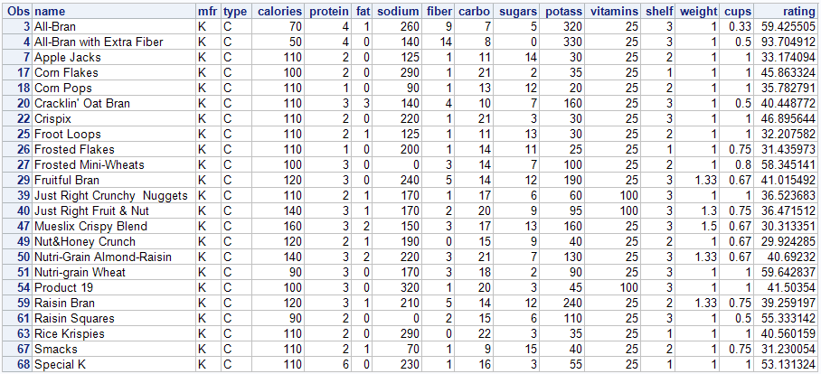

2b.

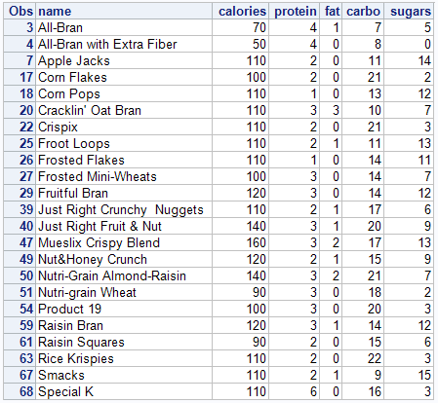

2c.

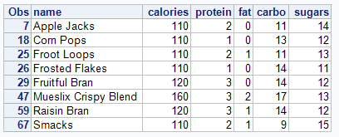

2d. Fruitful bran, Mueslix Crispy Blend, Raisin Bran, and Smacks

3a.

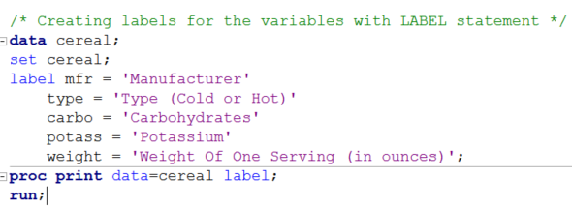

3b.

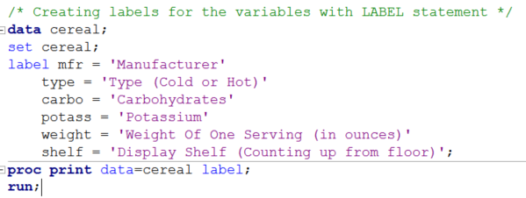

3d.

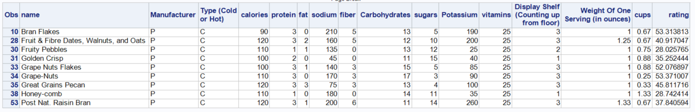

4a.

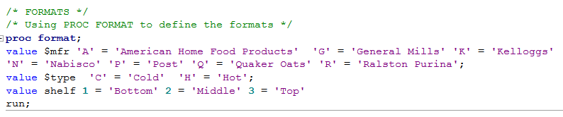

4b.

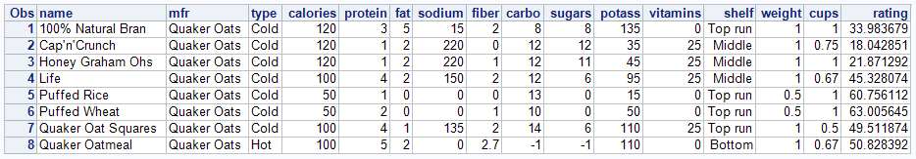

5. Most common word- **Bran**

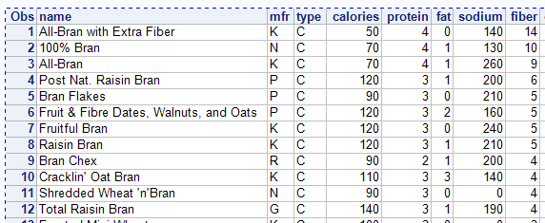

6.

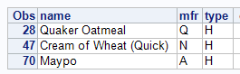

7a. Grape Nuts



7b.

It has a very high calorie and sodium count for the size of the serving

8. Most of the kids sugary cereal is right at eye level of the kids so they will try to get their parents to get this cereal for them.

9. It seems to be that the cereals with the highest fiber and the lowest sugar level have the best ratings. This also means that the cereals with the lowest fiber and the highest sugars have the worst ratings.

10a.

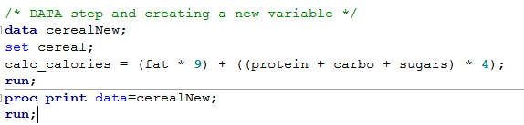

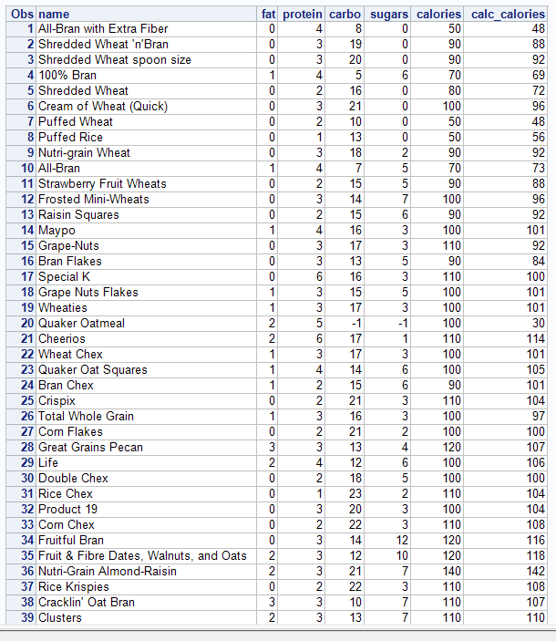

All cereals except Quaker Oatmeal are in a very close range of the calc_calories and the actual calories. The issue would most likely be the (-1) value that is in the sugars and carbo

10b.

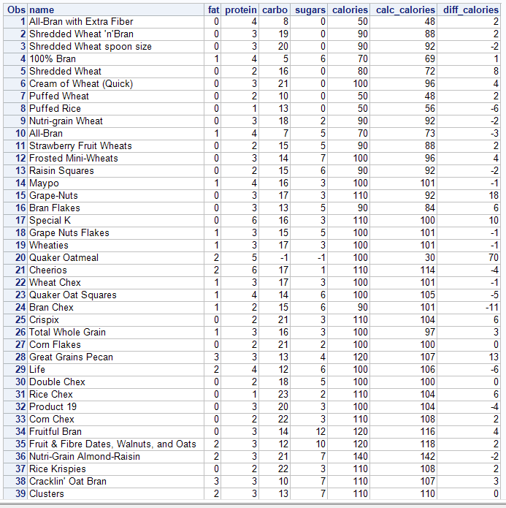

Quaker Oatmean is the only cereal outside of that 20 difference range. The negative values in place of sugars and carbo will offset this value.

11a.

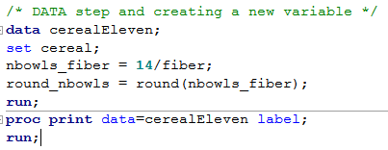

11b.

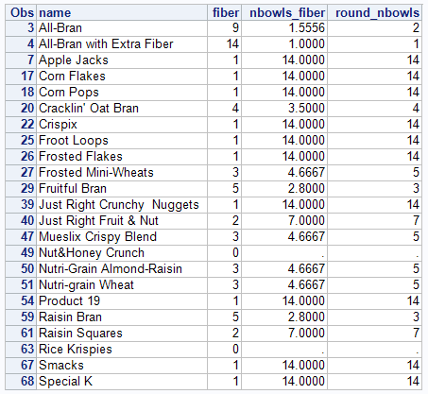

11c. This would be because the values of fiber are set to 0 in those cereals. This would give an error when doing the division.